HW10

Yichen Dong

November 8, 2018

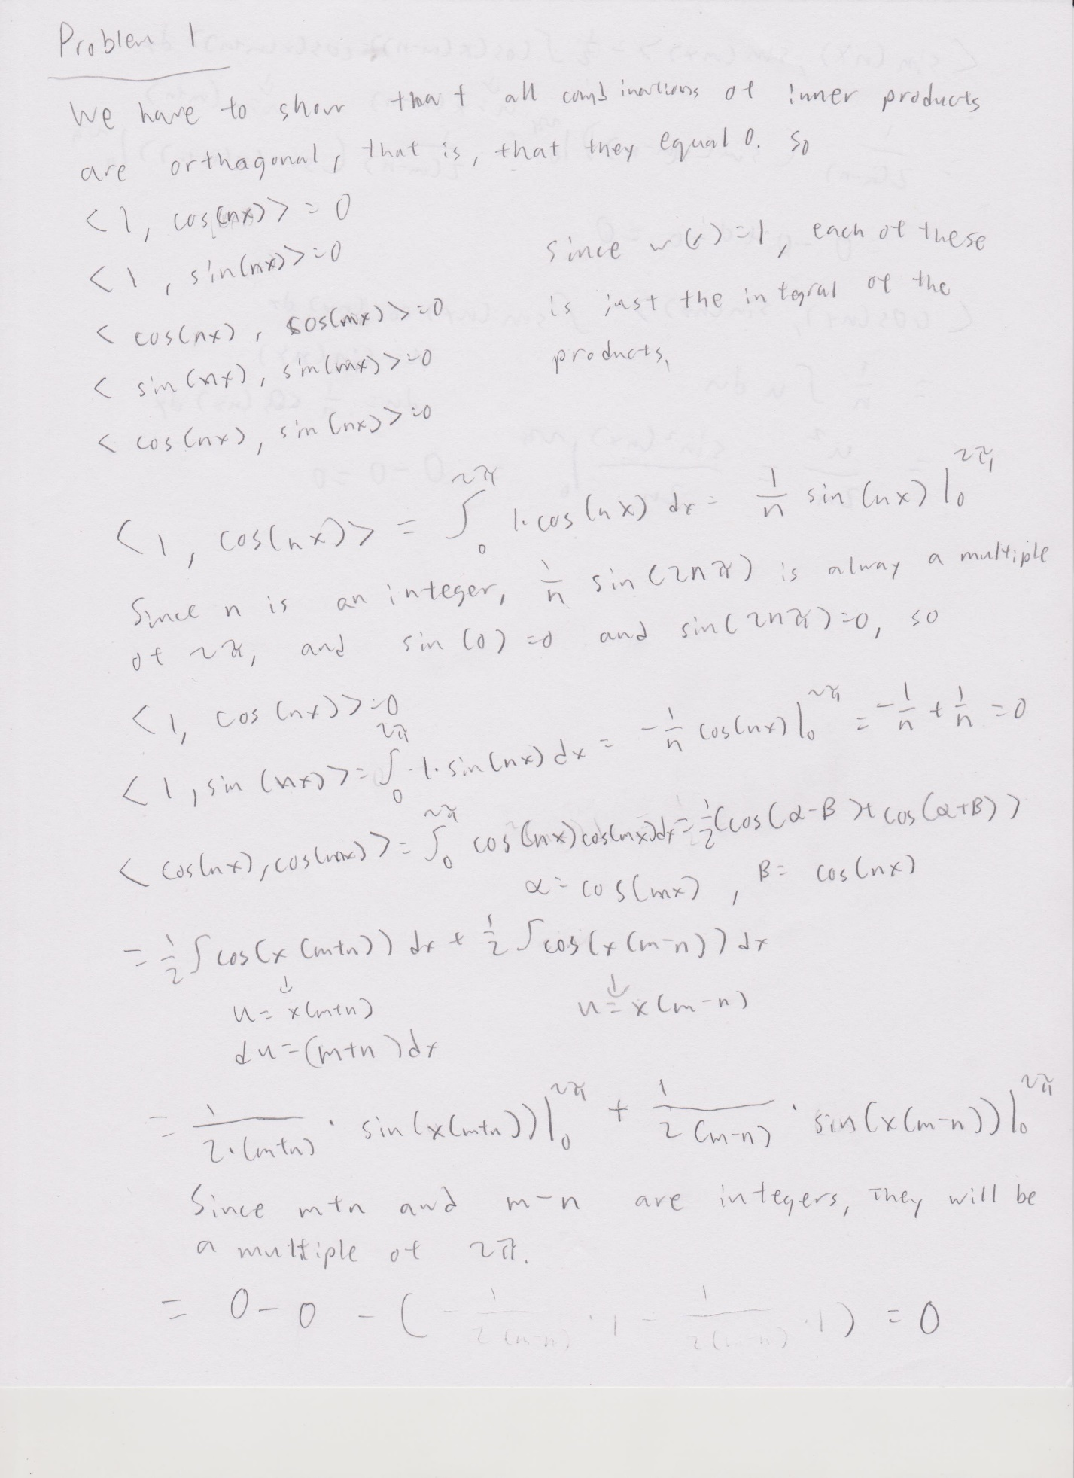

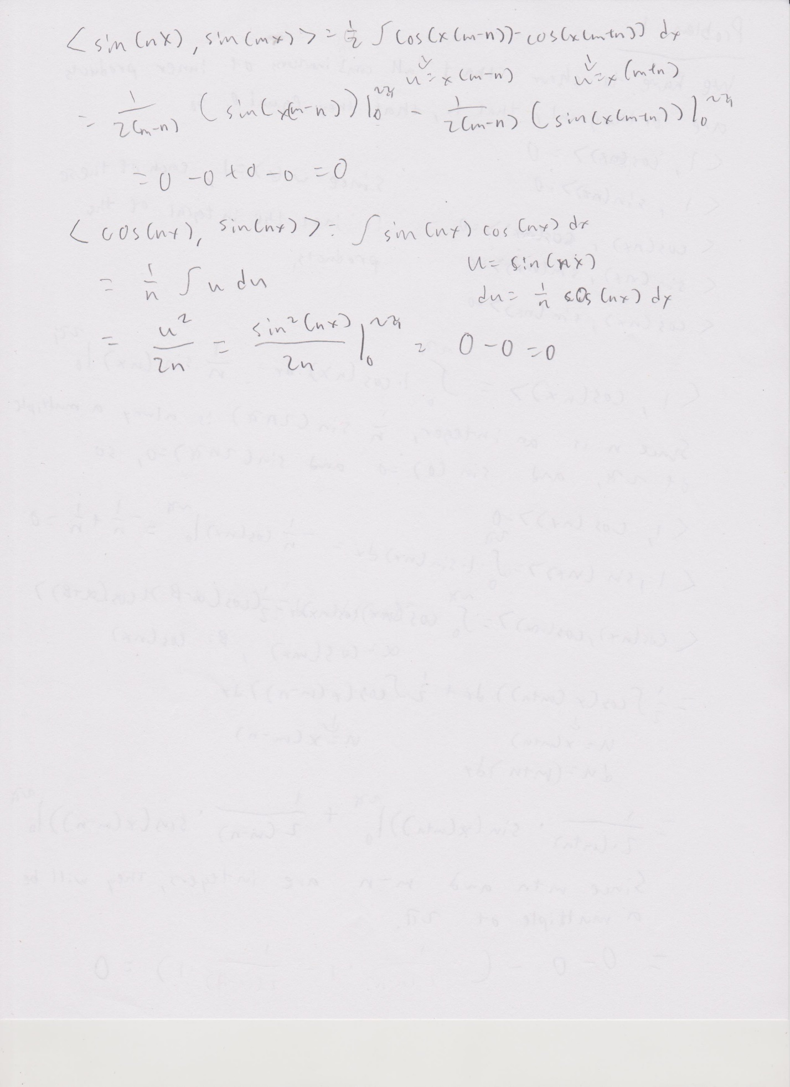

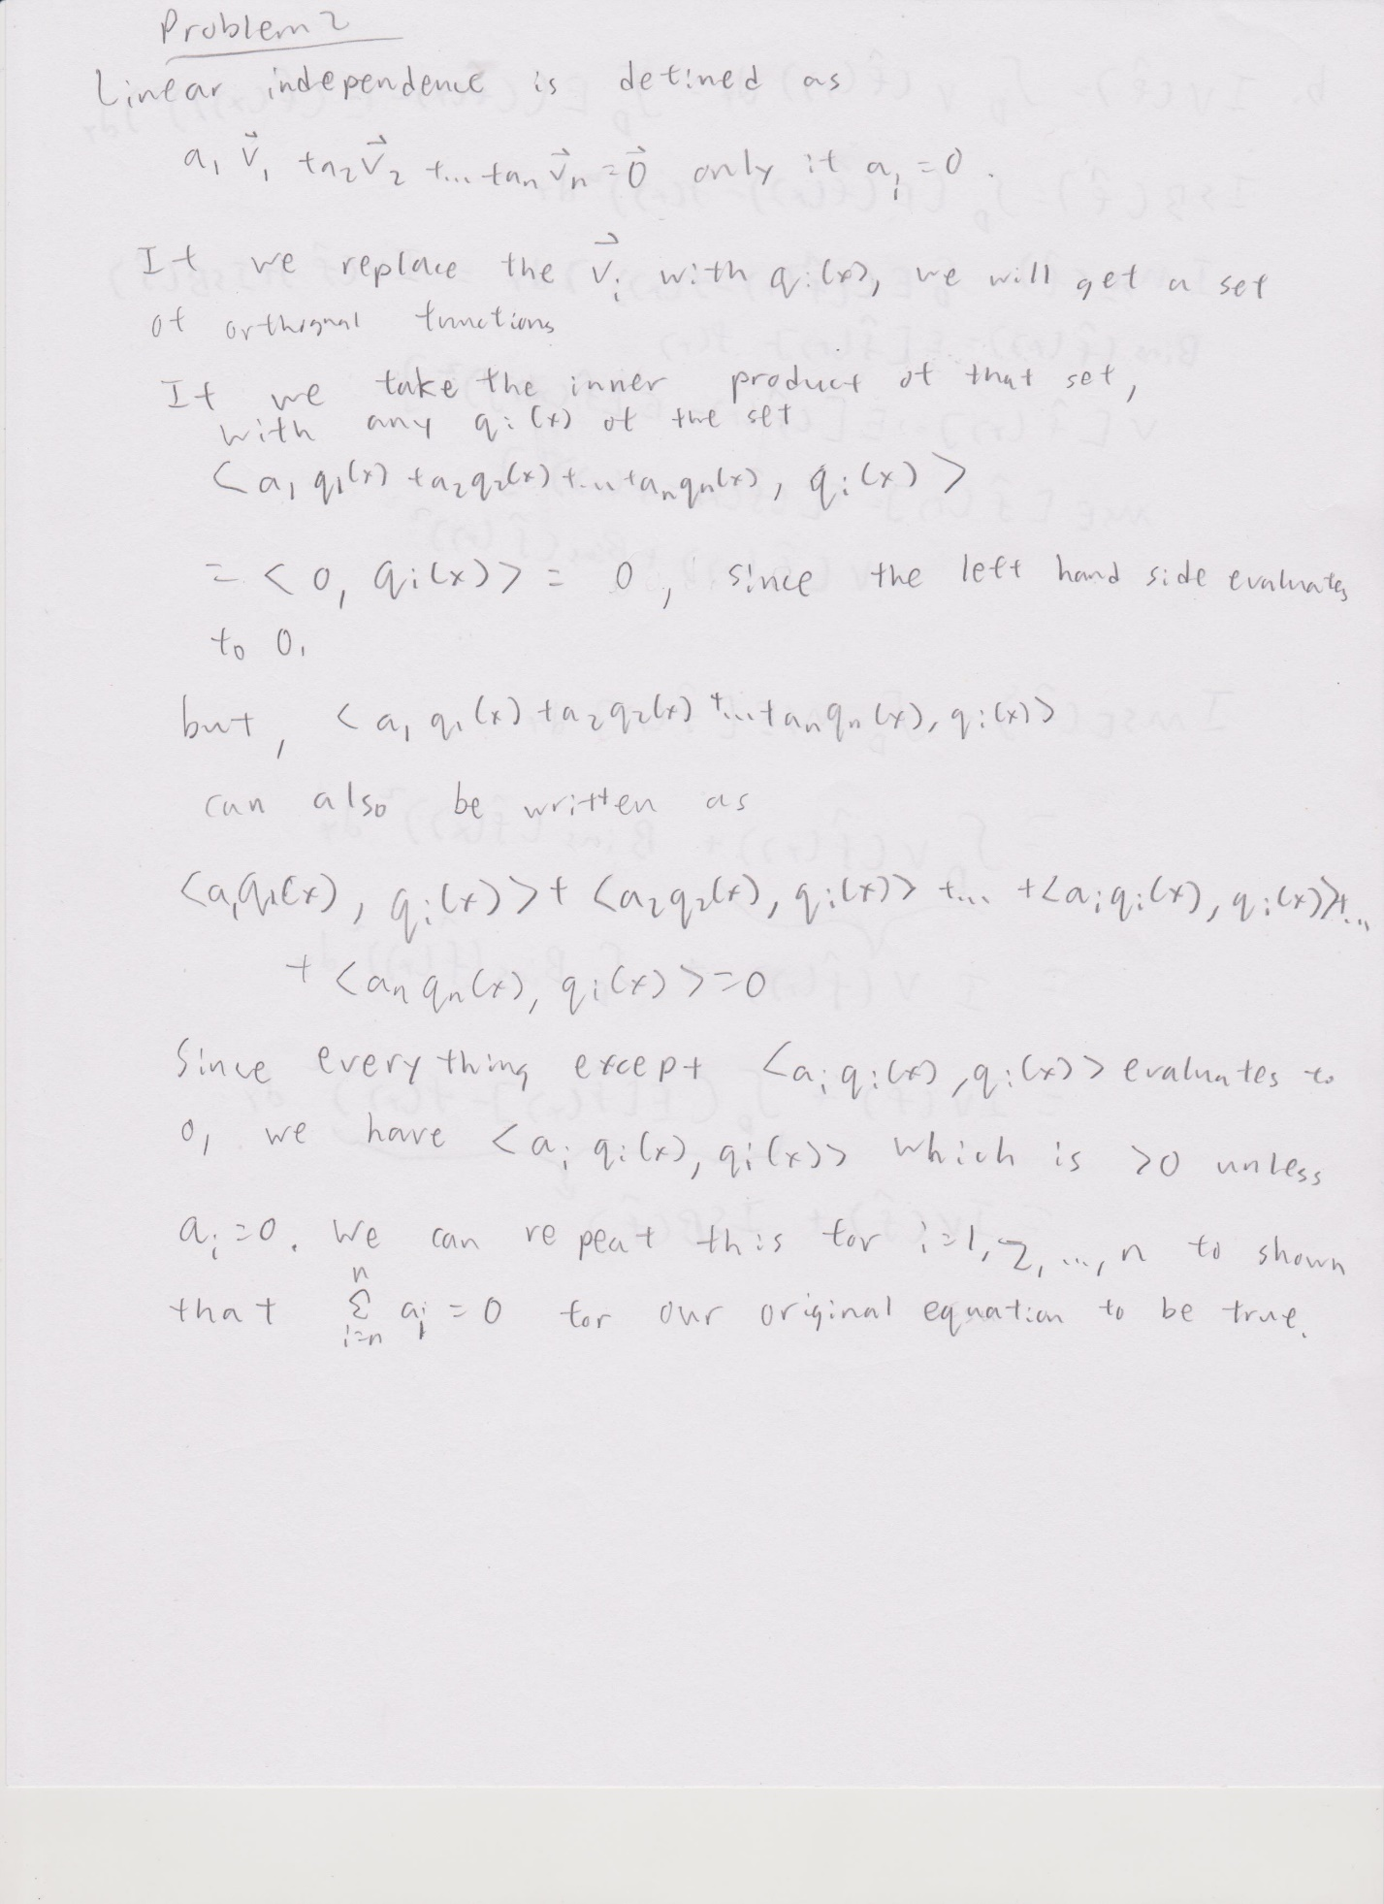

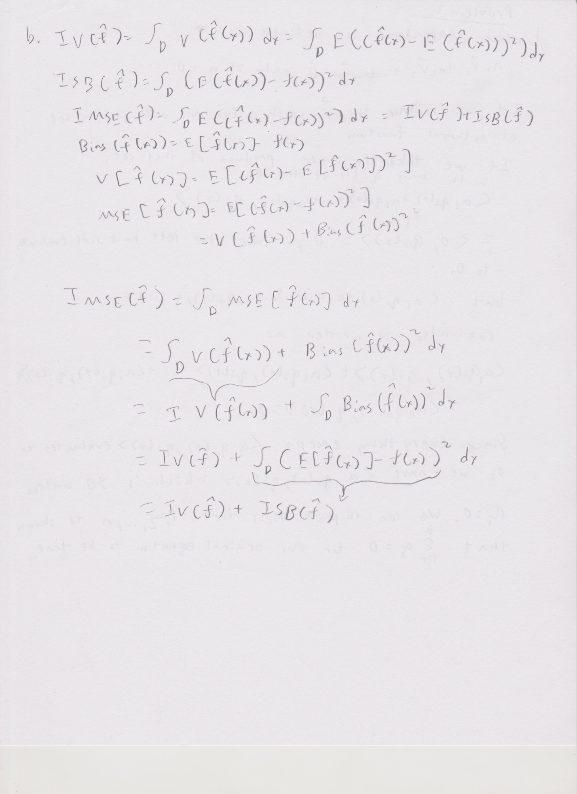

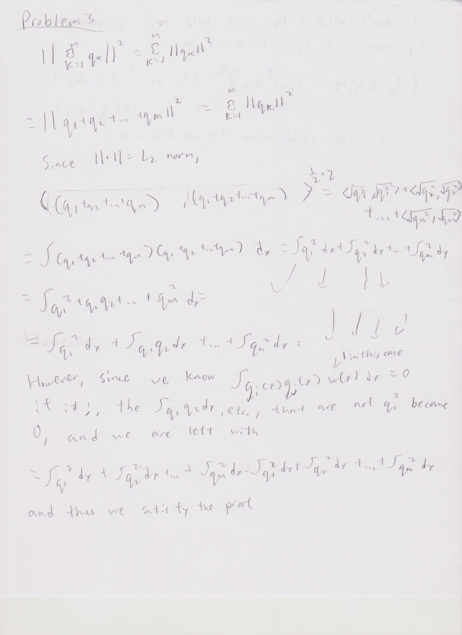

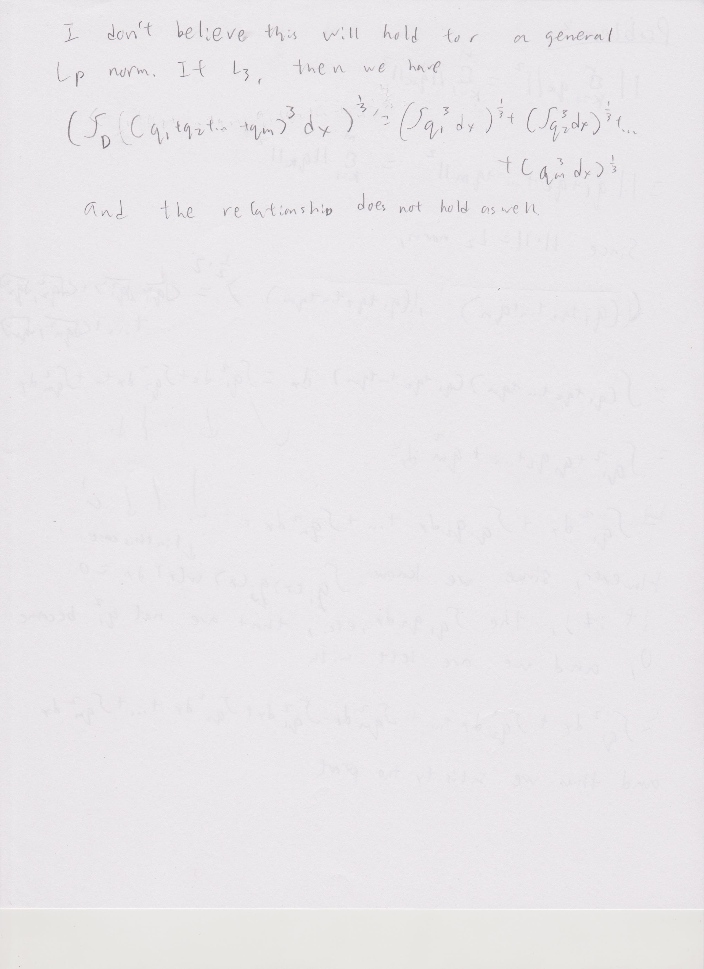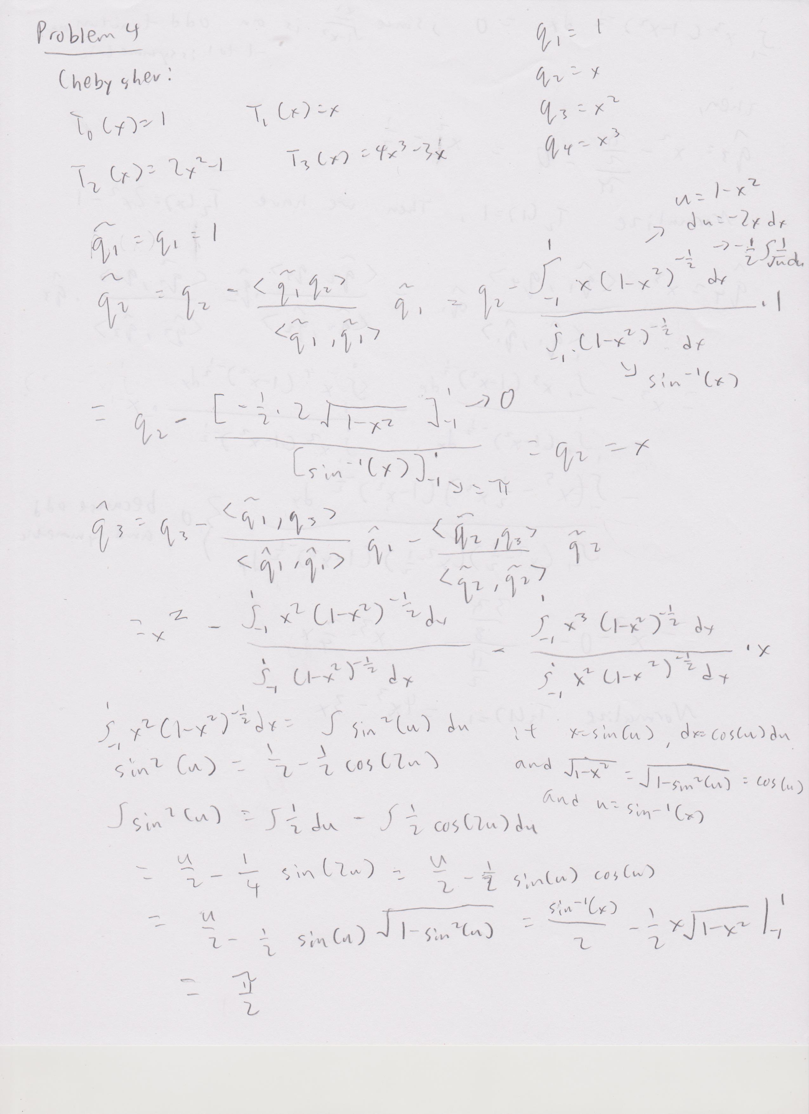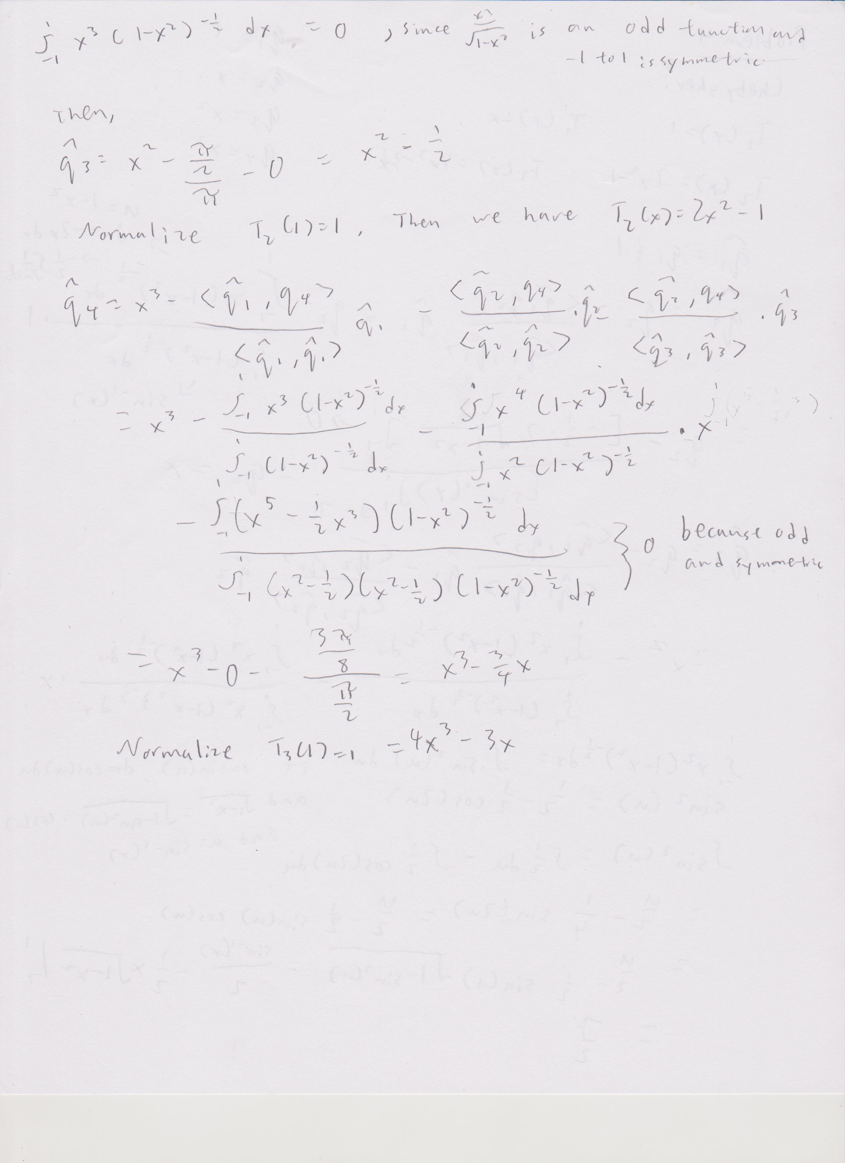

## Problem 4b

library(dplyr)

##   
## Attaching package: 'dplyr'

## The following objects are masked from 'package:stats':  
##   
## filter, lag

## The following objects are masked from 'package:base':  
##   
## intersect, setdiff, setequal, union

ortho = scan("Orthogonal.txt")  
q1 = function(x){1}  
q2 = function(x){x}  
q3 = function(x){2*x^2-1}  
q4 = function(x){4*x^3-3*x}  
g_x = function(x){dnorm(x,0,.3)}  
n = length(ortho)  
  
c_1 = 1/n*sum(q1(ortho)*g_x(ortho))  
c_2 = 1/n*sum(q2(ortho)*g_x(ortho))  
c_3 = 1/n*sum(q3(ortho)*g_x(ortho))  
c_4 = 1/n*sum(q4(ortho)*g_x(ortho))  
  
c_1

## [1] 0.9410636

c_2

## [1] -0.00415153

c_3

## [1] -0.8583737

c_4

## [1] 0.01297196

sum(c_1*q1(ortho))

## [1] 0.9410636

sum(c_2*q2(ortho))

## [1] 0.01014201

sum(c_3*q3(ortho))

## [1] 700.3602

sum(c_4*q4(ortho))

## [1] 0.1002212

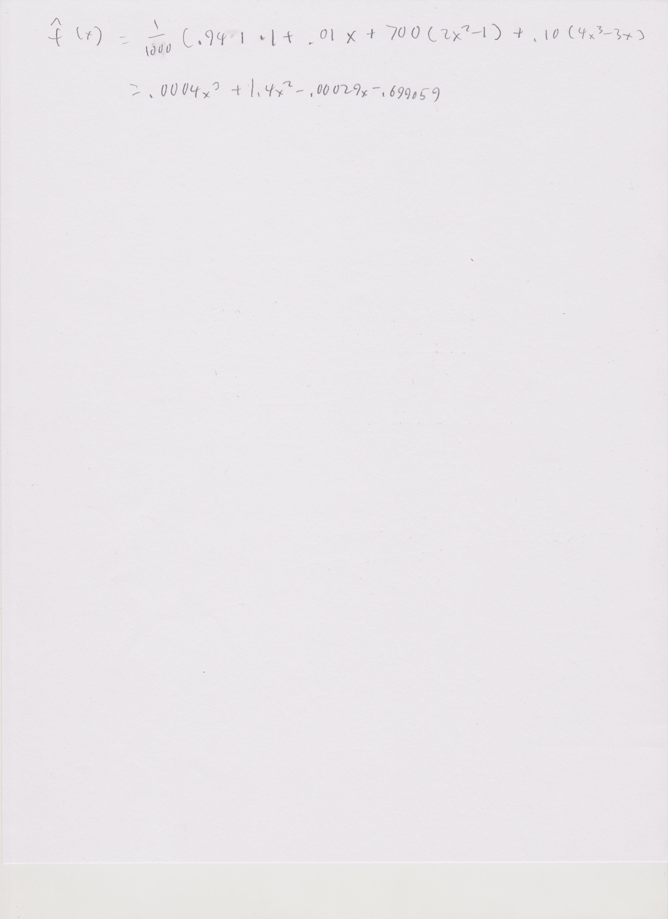

f_hat_x = function(x){.0004*x^3+1.4*x^2-.00029*x-.699059}  
ortho = as.data.frame(ortho)  
ortho = ortho %>%  
 mutate(f_hat = f_hat_x(ortho),  
 dnorm = dnorm(ortho,0,.3))

I definitely don’t think I did this right. I might have misunderstood what q(x) meant or what g(x) is supposed to be, because my answers do not make any sense whatsoever.

